**Practical No 1**

**Aim :** Execute the Disk Operating System (DOS) commands.

**Apparatus :**

A Laptop with Windows 11 operating system and user mode privileges. Access to command Prompt.

**Theory :**

**What is Disk Operating System?**

A disk operating system (DOS), is an operating system that runs from a disk drive. The term can also refer to a particular family of disk operating systems, most commonly MS-DOS, an acronym for Microsoft DOS.

**What are the various MS-DOS commands?**

1. **cd – cd(**Change directory), it is a command used to change the current directory in MS-DOS
2. **dir – dir(**Directory**),** it is a command used to view the files in present working directory.
3. **cls – cls(**Clear Screen**),** it is a command used to clear the screen of the command prompt.
4. **color –** it is a command used to change the color of the command prompt
5. **date -** it is a command used to show/ set date(Requires Administrator Privilages).
6. **time -** it is a command used to show/ set time(Requires Administrator Privilages).
7. **echo -** it is a command used to output text to Command Prompt
8. **hostname -** it is a command used to display the host name of the computer system
9. **mkdir -** it is a command used to create a directory
10. **rmdir -** it is a command used to remove an empty directory

**Output :**

1. **cd –**

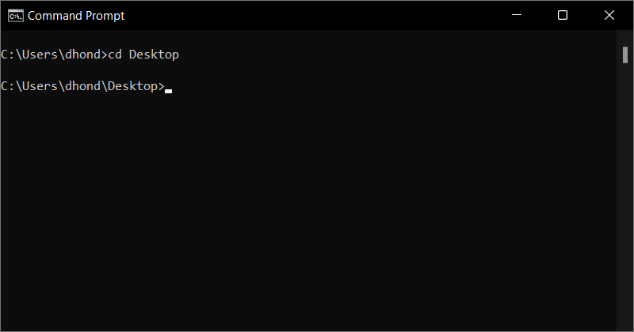

1. **dir –**

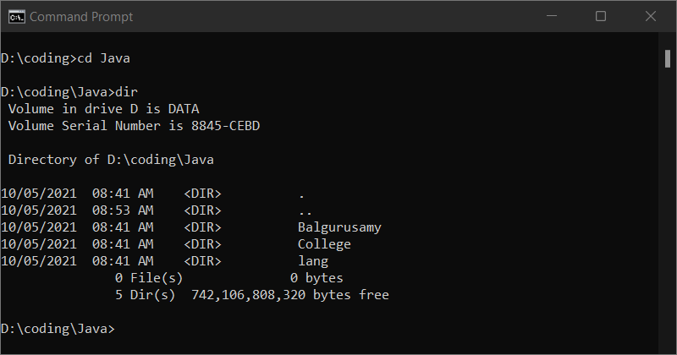

1. **cls –**

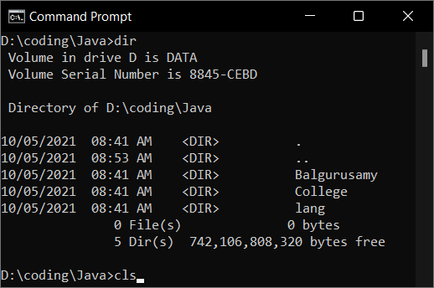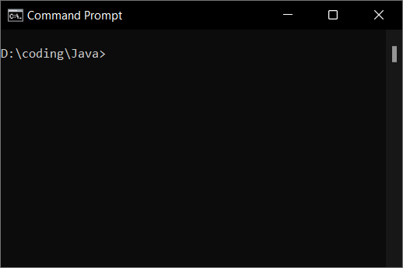

1. **color –**

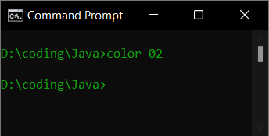

1. **date –**

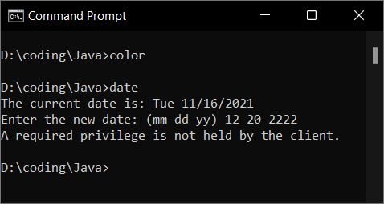

1. **time –**

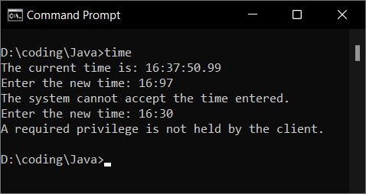

1. **echo –**

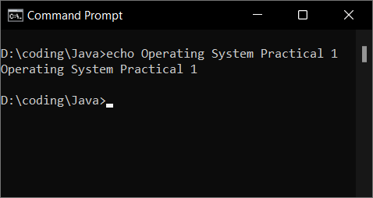

1. **hostname –**

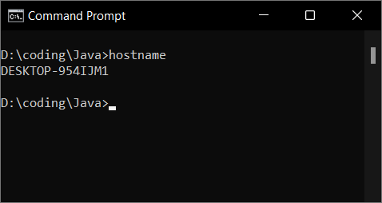

1. **mkdir –**

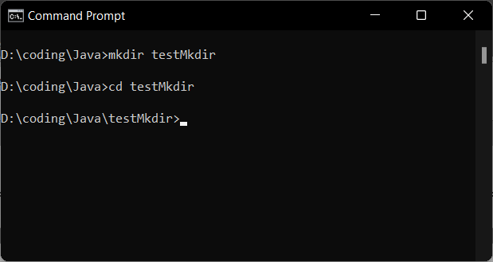

1. **rmdir –**

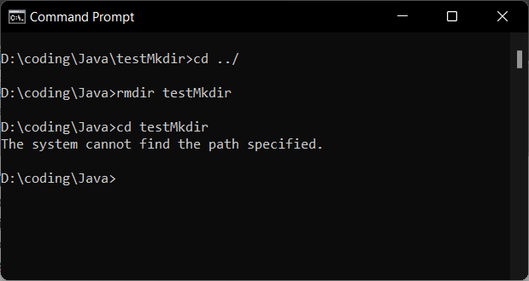

**Conclusion**:

Hence, by performing this practical I got to know about the concept of Disk-operating system, MS-DOS, and various commands of the disk operating system. I also executed few commands of the Disk operating system.